Assignment 12

Name: Prathmesh M. Sarwade

PRN: 22510050

Batch: T3

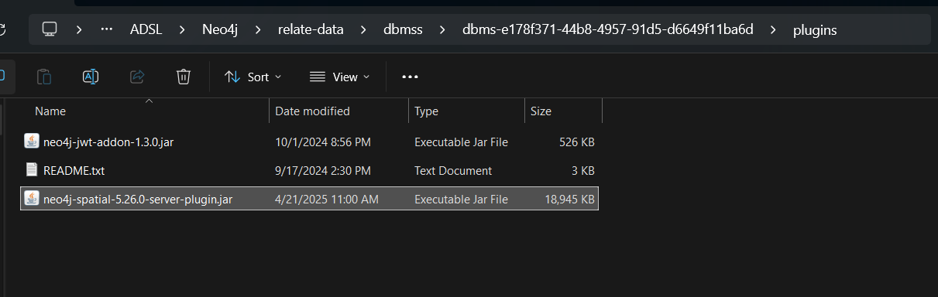

**Step 1: Create Sample Nodes:**

**CREATE (:TrainStation {**

**city: 'Copenhagen',**

**lat: 55.672874,**

**lon: 12.56459**

**});**

**CREATE (:Office {**

**city: 'Malmo',**

**lat: 55.611784,**

**lon: 12.994341**

**});**

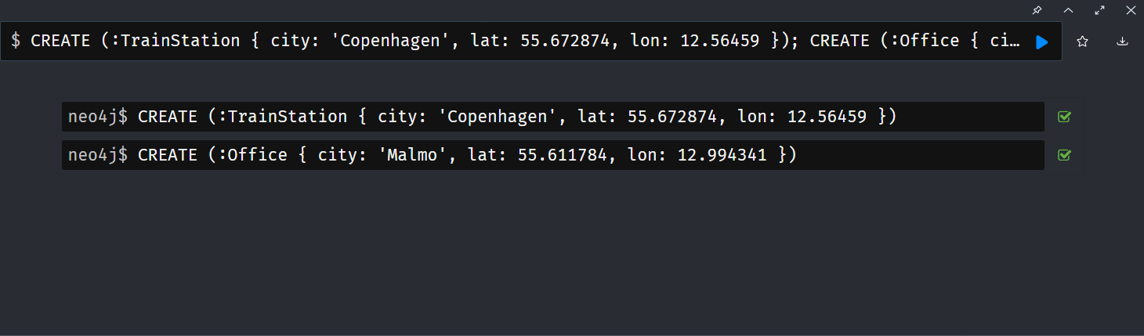

**Step 2: Create 10,000 Random Location Points:**

**UNWIND range(1, 10000) AS id**

**CREATE (:Location {**

**name: 'Location_' + id,**

**lat: 55.5 + rand() * 0.5,**

**lon: 12.5 + rand() * 0.5**

**});**

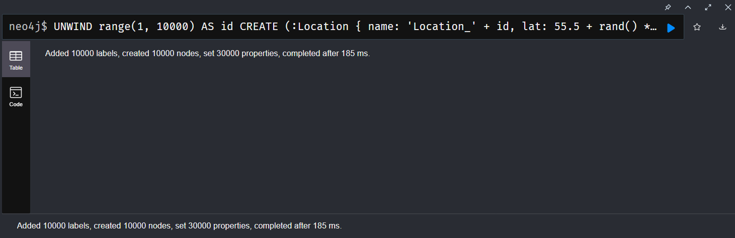

**Step 3: Create TRAVEL_ROUTE if within 10 km:**

**MATCH (t:TrainStation), (l:Location)**

**WHERE point.distance(**

**point({latitude: t.lat, longitude: t.lon}),**

**point({latitude: l.lat, longitude: l.lon})**

**) < 10000**

**MERGE (t)-[:TRAVEL_ROUTE]->(l);**

**MATCH (o:Office), (l:Location)**

**WHERE point.distance(**

**point({latitude: o.lat, longitude: o.lon}),**

**point({latitude: l.lat, longitude: l.lon})**

**) < 10000**

**MERGE (o)-[:TRAVEL_ROUTE]->(l);**

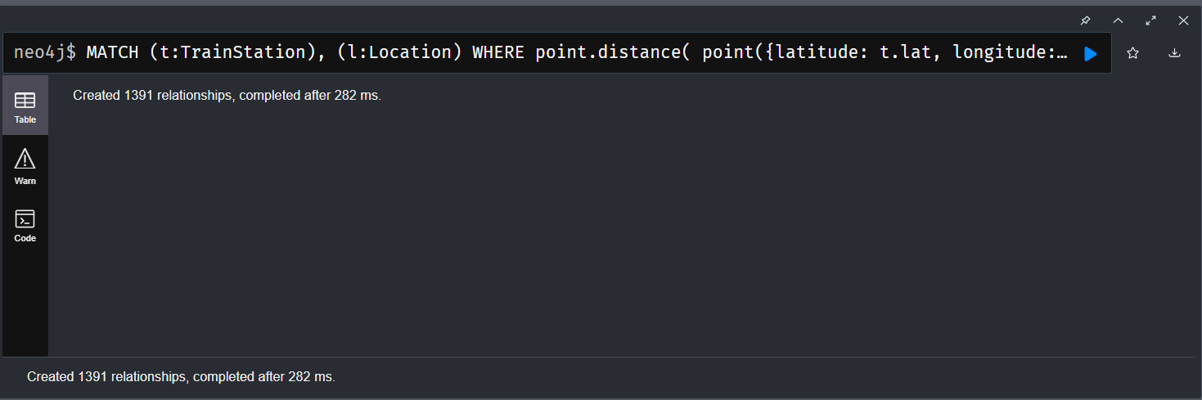

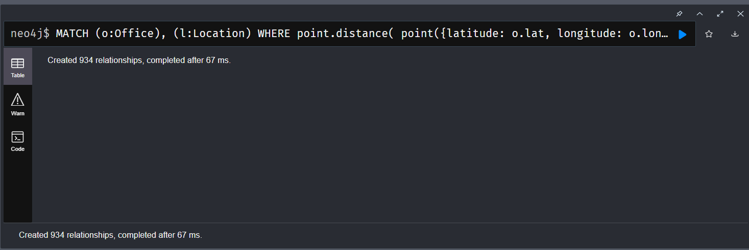

**Step 4: Show Which Things Are Nearest to What:**

**Top 5 nearest points to TrainStation:**

**MATCH (t:TrainStation), (l:Location)**

**RETURN l.name,**

**round(point.distance(point({latitude: t.lat, longitude: t.lon}), point({latitude: l.lat, longitude: l.lon}))) AS distance_meters**

**ORDER BY distance_meters ASC**

**LIMIT 5;**

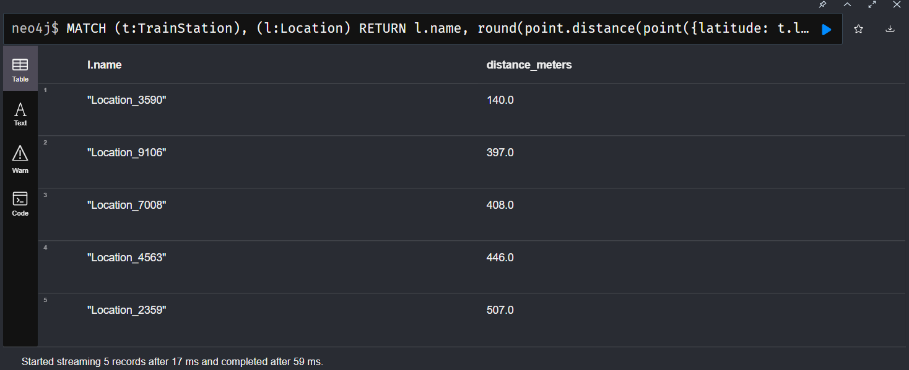

**All Locations within 5km of Office:**

**MATCH (o:Office), (l:Location)**

**WHERE point.distance(**

**point({latitude: o.lat, longitude: o.lon}),**

**point({latitude: l.lat, longitude: l.lon})**

**) < 5000**

**RETURN l.name, l.lat, l.lon;**

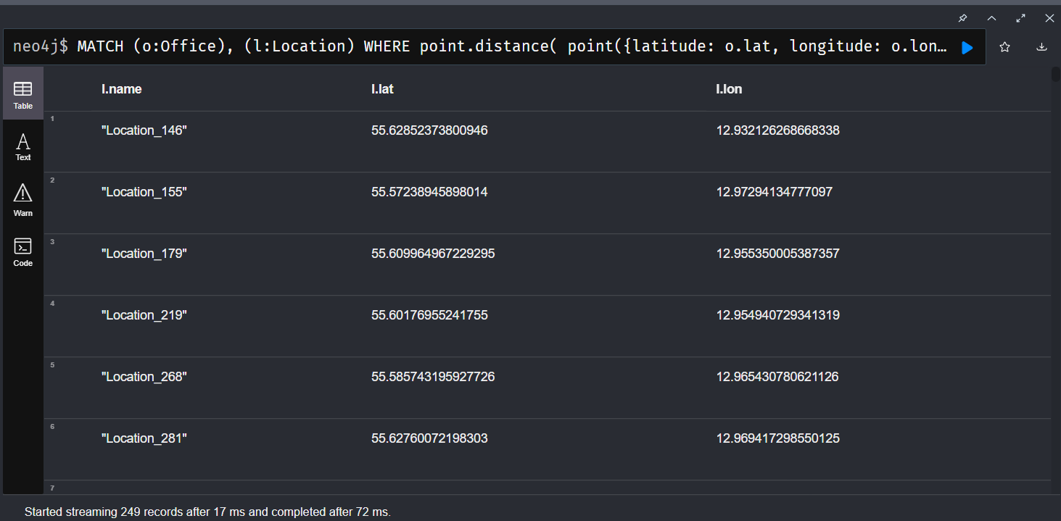

**Step 5: Display Relationship Graph:**

**MATCH (a)-[r:TRAVEL_ROUTE]->(b)**

**RETURN a, r, b LIMIT 100;**

